Case 1

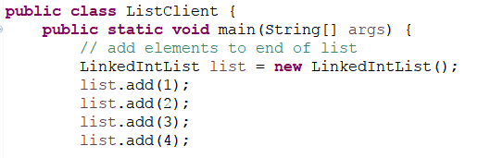

Output

list

3

4

2

1

Case 2

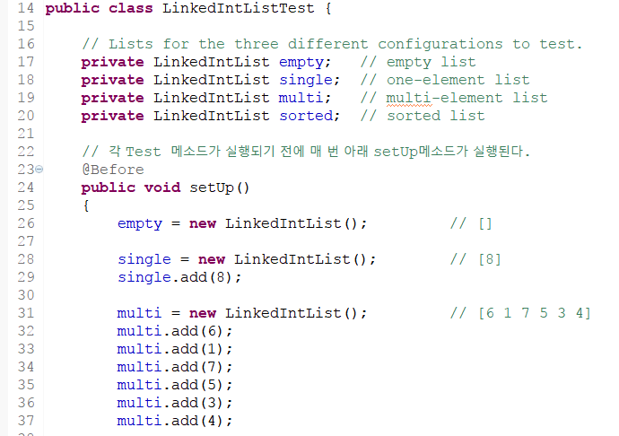

Input Variable Name: multi

Output

multi

4

3

5

7

1

6

Case 3

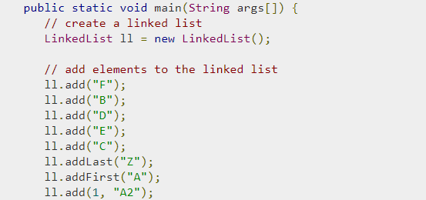

Input Variable Name: ll

Output

ll

E

D

B

F

A2

A

Z

C

Case 4

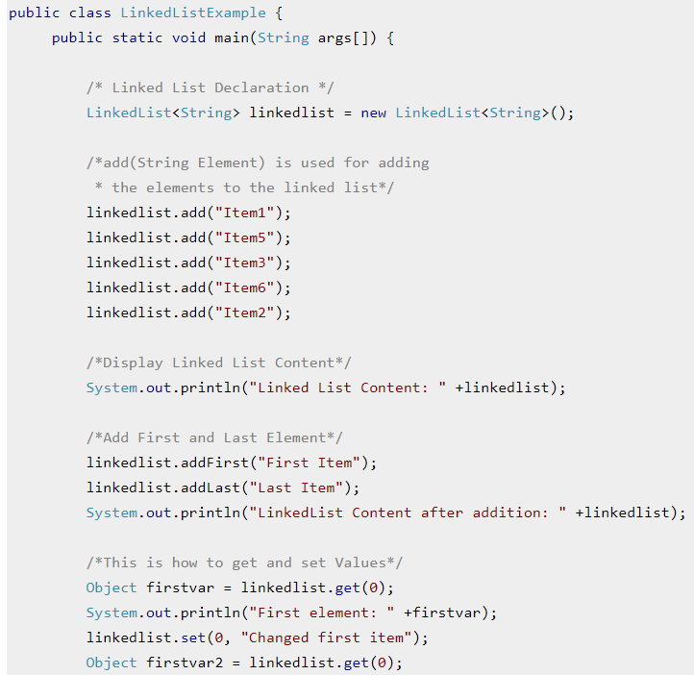

Input Variable Name: firstvar2

Output

firstvar2

Changed first item

Case 5

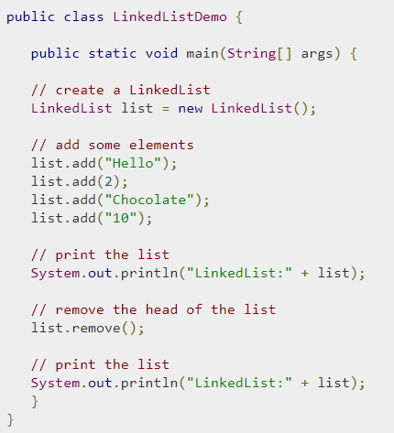

Input Variable Name: list

Output

list

10

Chocolate

2